Draft Competitive Analysis: Habitat for Humanity
Sarah Glazer, Pam Kahl, Madeline Moy, Elizabeth Noagi, Helen Pitlick
May 5, 2010 | COM 585: Web Tools For The Digital World

Habitat for Humanity is an organization plagued by popular misperception. Unlike many non-profits, it does not have trouble recruiting volunteers or raising funds because its brand is a household name. However, the common view of the organization does not completely mirror its mission. The organization wants to move beyond the belief that it donates homes to the poor when in actuality it sells homes to needy families who have proven their financial stability.
In a slideshow titled “Expressing the accomplishments of our work,” the organization stated that it wants to go beyond the number of homes built and volunteers participating as measurements of success. It also wants the public to become aware of its reach, its efforts to achieve LEED Gold certification in new projects, the profit margin of its Home Improvement Outlet, its role in educational outreach opportunities, and its ability to draw funding from a variety of sources.
We started by analyzing Habitat for Humanity’s website. We also selected a number of organizations we thought would be competitors in terms of volunteer time, donations, and grants. These organizations are not necessarily focused on the same goals as HFH, though they are all in the greater Seattle area. We also asked HFH for their perceived competitors, and analyzed a cross-section of both.
The criteria we used to examine each competitor are whether the site has a call to action, social integration, e-newsletter, visual design, and overall effectiveness. Presented in this document is an analysis of these competitors.
***
Org name: Habitat for Humanity, Seattle
Site name and URL: Habitat for Humanity, http://www.seattle-habitat.org
Mission Statement: Habitat for Humanity is a well-known organization that builds affordable housing for low-income families. It redevelops areas that are in need of housing, as well as coming to aid to communities that have suffered destruction or force of nature. Lastly, its mission is to build communities and families from various ethnicities, incomes and need.
Tag Line: No real tag line
Audience (your deduction): Younger audience for this organization. It has college students and recent graduates that want the opportunity to volunteer with this organization in other countries to have those opportunities in life. Another audience is the families who are looking to have the opportunity for the low-income housing.
Business/Site Goals (your deduction): Habitat’s primary goal is to get additional donations, tools and supplies. Even though its need is for volunteers like other non-profit organizations, its biggest goal is to have access to continuous supplies and materials. Without them, building houses becomes quite problematic. In addition, it needs to work with the government and larger companies that could sponsor these homes/communities to make sure that they are no mortgage homes.
Technologies used (your deduction): E-commerce with the Donate Buttons, Form script, Google Analytics
Homepage screenshot:
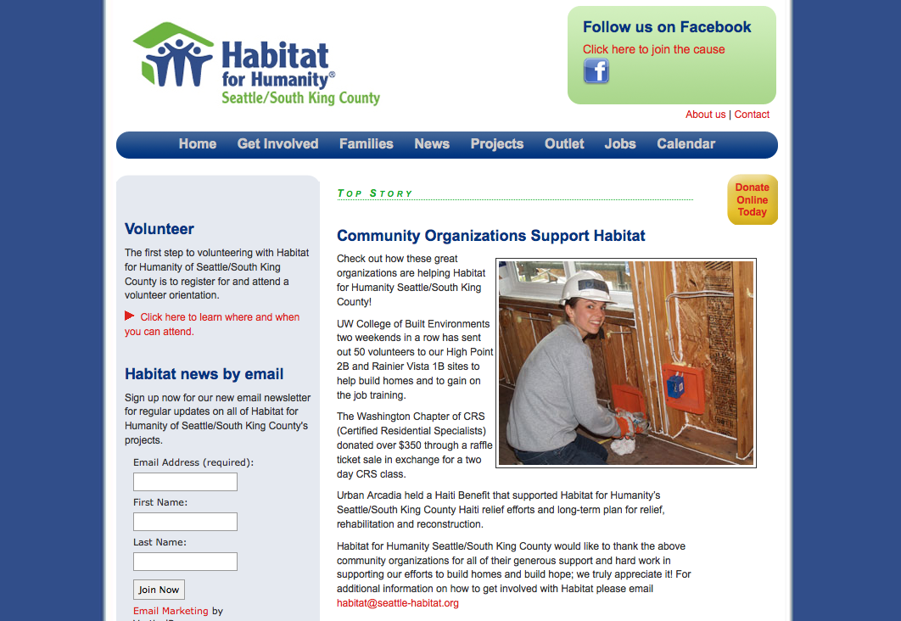
Criteria:
Call for action: Sign up for Volunteer, News via email, Donate Button,
Social integration: Yes, Facebook which appears on the top of the homepage.
E-newsletter: Yes
Search Feature: No
Visual/design: Seems pretty stale. For being such a well-known organization, one would think that Habitat would have a more up-to-date design, and a more engaging site. This doesn’t seem professional, nor does it give any good call to actions. Habitat for Humanity has the ability to show up high in the SEO search results, yet its website tends to leave the viewer at a dead end. There are no videos, barely any images and no diversity of fonts or color. It is not a visually stimulating site-- just one with a lot of text.
Overall: Habitat for Humanity can utilize its resources to build a well-integrated site that engages viewers all income levels, as well as becoming an informational resource. This unfortunately is not the case with the website now. If it wants to get additional funding on a much larger platform, it needs to update its site to be at least web 2.0. Also, the lack of call to actions contributes to its limited click through of the site. There are plenty of volunteer possibilities or ways to get involved, and it takes about three pages to even find out about them. Tell the audience what they should be doing upfront. That is why they come to the Habitat for Humanity site in the first place: to find out what they can do to help.

Org name: YouthCare
Site name and URL: YouthCare – Shelter Support Success, http://www.youthcare.org/
Mission Statement: YouthCare is looking to build awareness and confidence in the homeless community. It is an organization that wants to promote self-sufficiency for homeless people and encourage that support from all sides of the community. YouthCare focuses on the youth, to build a better life for the future of the community. One of its major goals for sustaining self-sufficiency with the youth is with education. That within itself provides awareness and confidence to get work, a place to live and function in society.
Tag Line: Shelter. Support. Success. Ending Youth Homelessness – building better futures
Audience (your deduction): The main audience for this organization is middle age, 30-40’s, that have a middle class income and are willing to donate their time to help out. YouthCare is also looking for donors and sponsors but that is not its target audience, as they are not the main audience of the website. People who are looking to help with the community and homeless people are the ones who probably visit the site most frequently. LGBTQ youths have a huge impact on YouthCare since there is a very high rate of suicide among this youth group. Therefore the other audience of this organization are that of the LGBTQ community.
Business/Site Goals (your deduction): YouthCare’s main goals are to build a bigger volunteer community. It wants the support and outreach program that will assist in education, food programs and awareness. In addition, its main goal is to get donor support. Having the Melinda and Bill Gates Foundation as a huge supporter, YouthCare has the audience of other wealthy organizations and foundations to assist with donations, and sponsorships. In order for this to continue, it needs to keep up with events, social engagements and spotlight programs that can show donors and future sponsors all the success and work they have been achieving in order to keep getting additional donations.
Technologies used (your deduction): Javascript slideshows, Donate Button (e-commerce), Google Analytics, PHP,
Homepage screenshot:
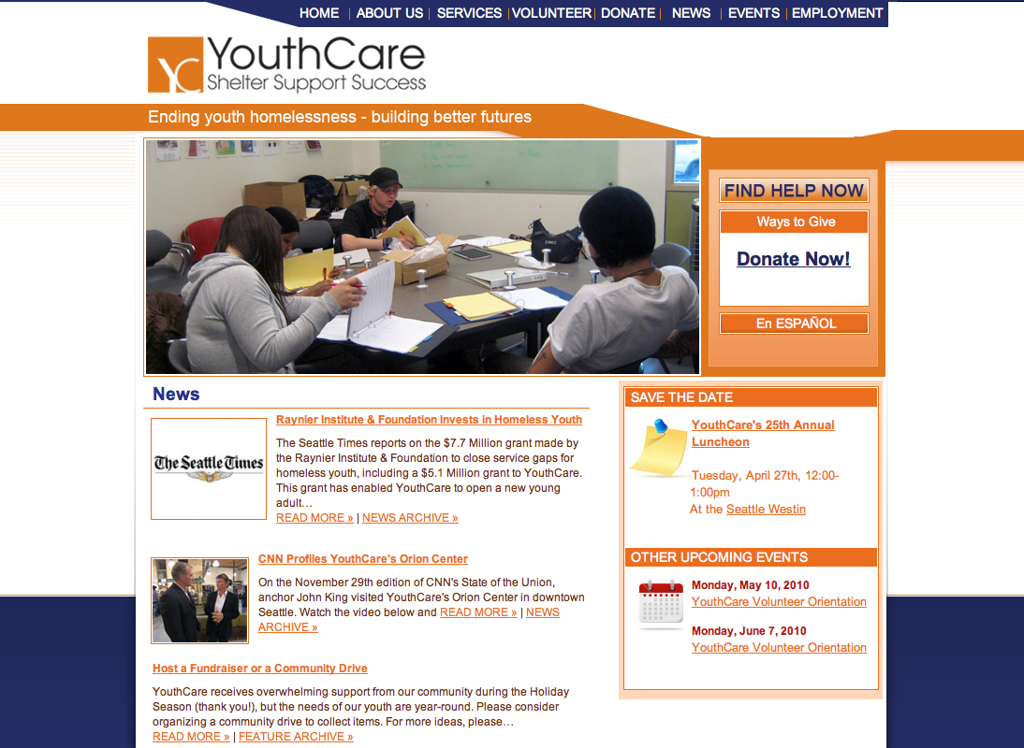

Criteria:
Call for action: Yes – Donate, Tell a friend, Volunteer Buttons,
Social integration: Not so much
E-newsletter: Yes – Newsletter, and tell a friend
Search Feature: No
Visual/design: Well, it seems very stale and outdated, although the slideshow on the home page is pretty encouraging for the youth, as well as having the news front and center. Otherwise, the colors are pretty basic and not too engaging. The website design tends to leave me with a lot of dead ends of what to do next.
Overall: This seems to be a static website, not a Wordpress site, although it could be incorporating PHP and MySql to incorporate CMS. The home page news section has updated news articles that are the most current but the links to read more doesn’t really take you anywhere, nor does it show other related news articles. The page just ends and you have to start over someplace else by going back to the navigation bar. This site does not engage the audience as much, with no real interactive videos or slideshows that are call to actions. This is not really working in YouthCare’s favor.

Org name: Hopelink
Site name and URL: Hopelink, http://www.hope-link.org/
Mission Statement: Hopelink combines numerous programs from housing, education, food, family development and assistance to help provide a diverse array of services to the community and people. Again, the key word used in Hopelink’s mission statement is self-sufficiency. With all these programs, the numerous possibilities of getting assistance is available all in one location which makes it easier to help get people back on their feet. This is a very strong element of the organization.
Tag Line: Helping People. Changing Lives.
Audience (your deduction): The audience is primarily middle class, middle aged professionals, as well as upper class professionals. But the majority of the people who get involved and engaged with this organization are middle class workers. People who want to make a difference and give as much of their time to gather new sponsors, or participate in a project.
Business/Site Goals (your deduction): Hopelink’s website goal is for engagement, teaching, and resources for its audience. This is a great benefit for non-profit organizations since their main goal is to educate the people about problems in society and ask for their contribution to help remedy these issues that affect all of us.
Technologies used (your deduction): Lots of javascript, php, form scripts as well as a CMS system in place to update the events and news resources.
Homepage screenshot:
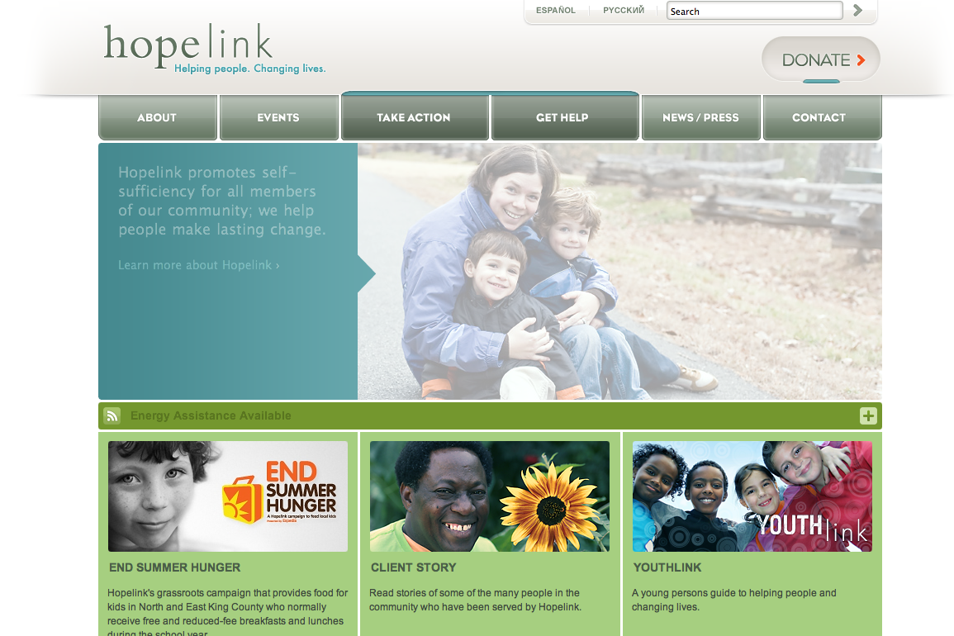
Criteria:
Call for action: Tons of call for actions. Each section has a “learn more” link as well as the newsletter signup on the home page. Quicklinks, donate tab, RSS feed and Free Text Relay for the Hearing Loss or Speech Disabled.
Social integration: Yes, 2 Facebook pages and a Myspace page
E-newsletter: Yes, although there is a requirement to login in first, which is not really the best tactic and would be curious to know the reasoning behind that.
Search Feature: Yes, a modern search feature is displayed at the top of the website.
Visual/design: Great design, positive colors. It shows happiness and hope, which is important when discussing hard situations. Obviously you want to stress the severity of these issues but as a visitor you want to see the good outcome when working with an outreach program. The colors are positive but not so offensively bright. The interactivity of the site shows that it is up to date with the latest Web 2.0 technology.
Overall: Great website. Not sure if all the latest interactive tabs will be recognized by all audiences. I didn’t even notice the plus sign that opens up the RSS feed. It is a great feature but I don’t think that all their audience is as web savvy. Another great part of this site is that it is available in multiple languages, and that tab is on the top of the site, easily readable by anyone who enters the site.
Another fantastic plus is legibility. This site is very easy to read, no straining of reading the text over the color and the navigation bar buttons are extremely large. This is great for Hopelink’s audience, making it easy for them to find and navigate through the website.
A few downfalls: The site’s RSS fee link does not work and in order for you to be on the mailing list—you need to become a member of the site. These are just a few problems that could lead to some dead ends within the site.

Org name: Food Lifeline
Site name and URL: Food Lifeline: http://www.foodlifeline.org/
Mission Statement: “Food Lifeline is a nonprofit organization dedicated to ending hunger in Western Washington.”
Tag Line: Feeding hope: feeding Western Washington
Audience (your deduction): The audience is most likely potential donors. The organization’s upcoming events receive much of the site’s real estate, and it is not obvious how to become a recipient of Food Lifeline’s services.
Business/Site Goals (your deduction): It’s fairly clear that this is an organization dedicated to ending (“stamping out”) hunger in Western Washington.
Technologies used (your deduction): CSS with shopping cart
Homepage screenshot:
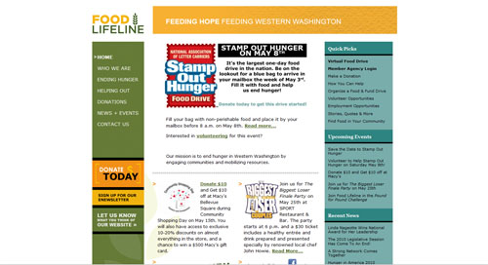
Criteria:
Call for action: a donate button in the left side bar
Social integration: reasonably clear links to Facebook, Twitter, and a Wordpress blog; a YouTube video in the “who we are” section.
E-newsletter: yes
Search Feature: no
Visual/design: Food Lifeline tries to cram a bunch of information on the homepage, with sidebars flanking both sides of the main section. This is orderly, though bordering on too much information to process at one time. The page has many different colors, which go well together but verge on excess. The right side of the header and the right sidebar do not match up, which looks like shoddy design, though the feel of the page is not unpleasant.
Overall: It’s not the worst website out there, but it’s a little hokey. Food Lifeline could benefit from a professional redesign.

Org name: Northwest Harvest
Site name and URL: Northwest Harvest http://www.northwestharvest.org/
Mission Statement: It’s clear that this site is aimed at preventing hunger in Washington State, based on the mission statement on the landing page. This reads, “Our mission is to provide nutritious food to hungry people statewide in a manner that respects their dignity, while fighting to eliminate hunger. Our vision is ample nutritious food is available to everyone in Washington State.”
Tag Line: N/A
Audience (your deduction): The site was designed by two separate design firms, Fitch and FGI, meaning Northwest Harvest is serious about their public appearance. It therefore seems geared more to potential volunteers and donors than potential recipients, though the latter are also included.
Business/Site Goals (your deduction): Raise money and food donations to end hunger in Washington State.
Technologies used (your deduction): CSS with blog and shopping cart; flash
Homepage screenshot:
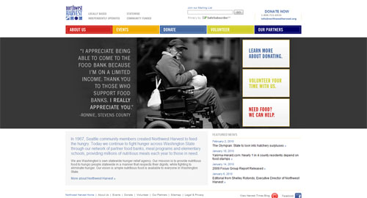
Criteria:
Call for action: Buttons leading to donate
Social integration: Icons lead to Facebook, Twitter and their blog
E-newsletter: Yes
Search Feature: None
Visual/design: The site is aesthetically pleasing. It’s clean, with ample white space, tasteful amounts of color and a gray bar that spans the entire browser. The most appealing aspect of the design is the prominently-featured, rotating images of food bank recipients, along with quotes. This creates an immediate connection with the organization. The only drawback is that the Eenewsletter is in the position that a search bar would ordinarily occupy, potentially leading to confusion.
Overall: It comes off as a well-designed, effective website. A search bar would be nice, but it’s structured enough that it is not really necessary.

Org name: Big Brothers Big Sisters of Puget Sound
Site name and URL: Big Brothers Big Sisters of Puget Sound, https://www.bbbsps.org/NetCommunity/Page.aspx?pid=191
Mission Statement: “Big Brothers Big Sisters of Puget Sound partners with actively involved community members to match caring adults with children, both of whom benefit from our one-to-one mentoring programs.”
Tag Line: “Be Big!”
Audience (your deduction): There are two main audiences: people who are interested in becoming a big brother or big sister and people who want to enroll children in a Big Brother Big Sisters mentoring program.
Business/Site Goals (your deduction): The main goal of the site is to recruit volunteers. The organization also seeks to raise money, build community and create mentoring advocates.
Technologies used (your deduction): II6, JQuery Validate, JQuery, ASP.NET, Shockwave Flash Embed, ASP.NET Ajax, XHTML Transitional, CSS, Javascript, UTF-8.
Homepage screenshot:
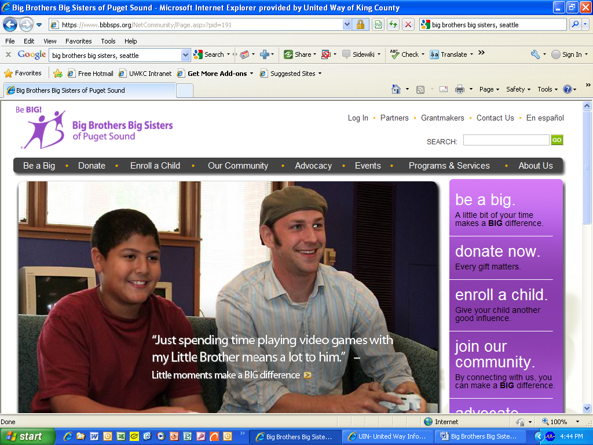
Criteria
Call for action: The Big Brothers Big Sisters of Puget Sound site is heavily geared toward recruiting volunteers. The first thing users see on the home page of the site is a big, appealing photo of a volunteer “big brother” and his “little.” Click on the link in the photo, and it goes to a page that describes the impact volunteers make in kids’ lives.
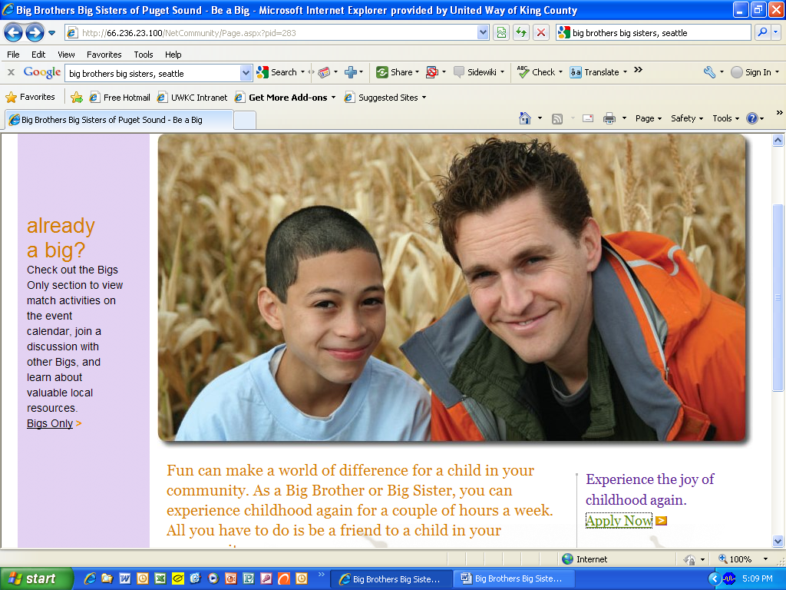
The home page photo is one of three, which all feature a volunteer with a child, a quote from the “big” or the “little” and a link to learn more about becoming a volunteer with Big Brothers Big Sisters.
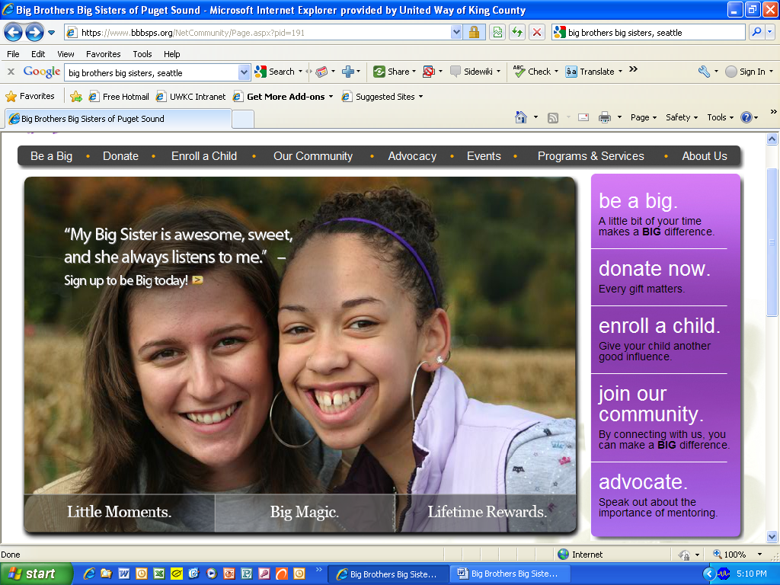
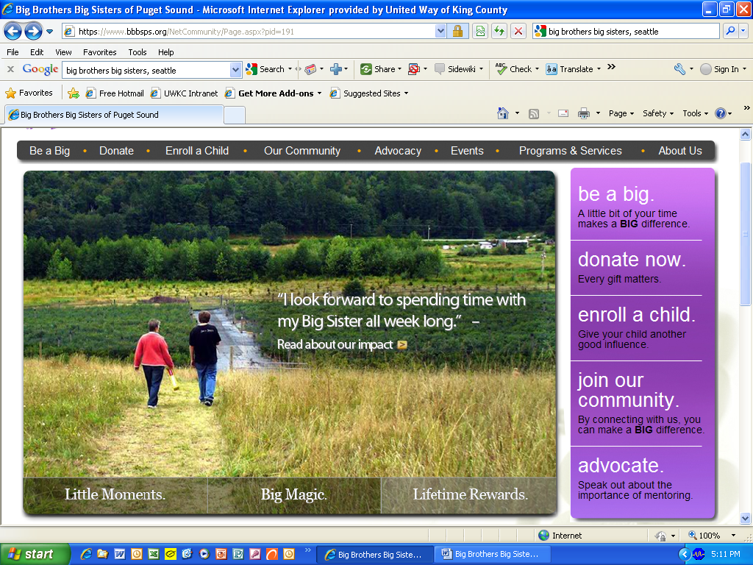
While the push is to sign up volunteers, the Big Brothers Big Sisters site also offers many other ways to get involved. Users can donate, join the Big Brothers Big Sisters online community, attend an event or become an advocate for mentoring.
Social integration: Big Brothers Big Sisters is working to develop its own online community through its site. It asks users to “join our community” and create a personal account.
“Our Community is a place for everyone who makes a BIG difference with Big Brothers Big Sisters of Puget Sound. This section of our website features an active discussion board where you can discuss issues related to mentorship, a variety of BBBS e-cards that you can send to friends, and a ‘Submit Your Story’ feature that allows you to tell us how mentoring has affected your life. Other features include the ability to create and customize your profile, view a history of your tax deductible donations and print receipts, and update your contact information easily.”
The organization has a Facebook page, and 353 people “like” Big Brothers Big Sisters of Puget Sound. It has frequent status updates but not a lot of discussion.
Big Brothers Big Sisters uses Twitter and has 307 followers. It also has a YouTube channel with 580 channel views and 1,820 total upload views.
E-newsletter: I did not see the ability to subscribe to an e-newsletter on the site.
Search feature: There is a search box in the upper right corner of each page.
Visual/design: The use of color photography is engaging and clearly conveys the purpose of the organization. Diversity is represented in terms of age, race and ethnicity and gender.
The site design employs negative space to good effect. There are a lot of elements on each page, but the negative space breaks it up and doesn’t make it look crowded.
Type is big and easy to read, and pages are not text heavy.
Navigation is clear and easy to use.
Overall: Big Brothers Big Sisters of Puget Sound has a compelling website that has the ability to catch the attention of people who want to donate their time and/or money to a nonprofit organization.

Org name: Boy Scouts of America Chief Seattle Council
Site name and URL: Boy Scouts of America Chief Seattle Council, http://www.seattlebsa.org/
Mission Statement: The mission of the Boy Scouts of America is to prepare young people to make ethical and moral choices over the lifetimes by instilling in them the values of the Scout Oath and Law.
Tag Line: “100 Years of Scouting”
Audience (your deduction): The primary audience for this site is parents of current Boy Scouts and scout leaders. The site is also geared toward parents who want to learn more about the program. Secondary audiences include Boy Scouts alumni, potential volunteers and donors and people who just want to generally know more about the Boy Scouts.
Business/Site Goals (your deduction): The purpose of the site is to provide parents and scout leaders with information updates (event calendar and registration, program information) and resources that will help them be successful (online training). The site is also a recruitment tool for families that are interested in the joining the organization.
Technologies used (your deduction): Apache, Google Analytics, Javascript, PHP, RSS, Atom, Meta Robot, Meta Description, Meta Keywords, XHTML Transitional, CSS, UTF-8
Homepage screenshot:
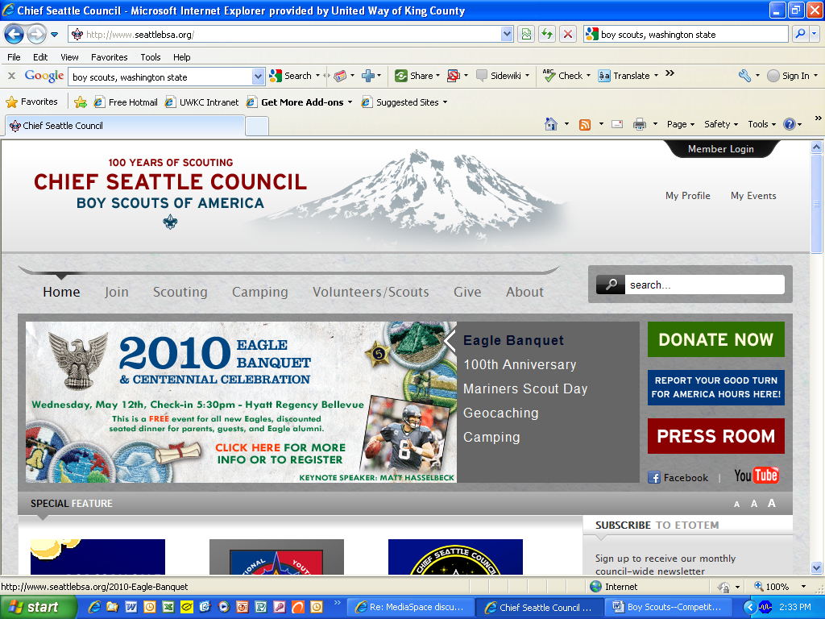

Criteria
Call for action: There is no clear call for action, but there are three prominent buttons in the right column, which leads me to believe these are the most important pieces of the site (“Donate Now,” “Report Your Good Turn for America Hours Here,” and “Press Room.” It appears that the organization wants people to donate, it wants scouts to report their service hours and it wants people to read its positive press coverage.
Social integration: Under the three prominent buttons in the right column, there are icons for Facebook and YouTube. The Chief Seattle Council has a modest Facebook page, with 306 people who “like” the organization. It looks like the page was recently created in January 2010.
The YouTube link goes to the national Boy Scouts of America YouTube channel, which is fairly extensive but not localized. It has had nearly 50,000 channel views and nearly 113,000 upload views.
In the upper right corner, there is a “Member Login” and “My Profile” and “My Events,” so perhaps there is some closed community networking taking place through the site.
E-newsletter: Users can sign up to receive “Etotem,” which is a council-wide, monthly newsletter.
Search feature: A search box is located in the right corner of the site in plain view.
Visual/design: The site holds a lot of information, and it’s easy to navigate using the drop-down menus that appear when you click on each part of the horizontal navigation.
The majority of the webpages are fairly text-heavy or only feature small graphics or photos. Using more photos or at least making them larger could improve the site’s visual appeal. The home page does its job, but the design is blah and doesn’t encourage users to scroll down to read the news section.
The “Special Feature” graphics look dated and the colors clash with the darker green, blue and red used in the “Donate Now,” etc. buttons.
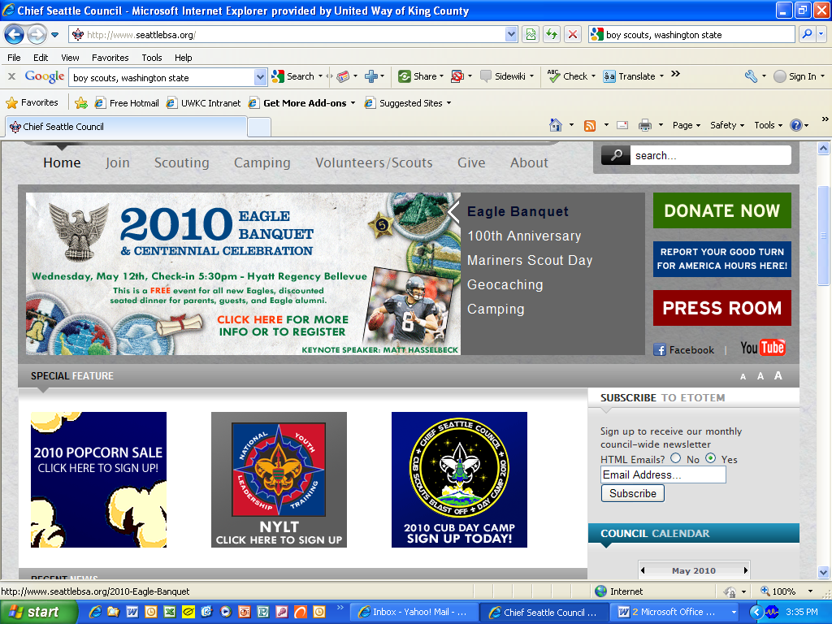
The press room page is the most visually interesting, and it’s not clear why the rest of the site doesn’t have more of these kinds of vivid design elements.
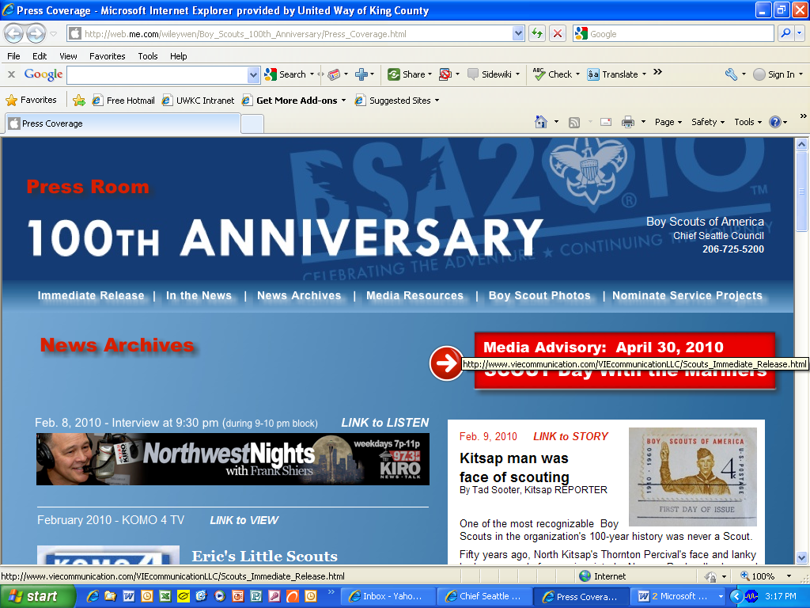
Overall: If you are already involved in Boy Scouts, this is probably a very useful site. If you are looking to join, volunteer or give, it’s not very compelling. The site is not visually interesting, does not tell the story of the Chief Seattle Council and does not provide reasons for new people to get involved.

Org name: Plymouth Housing Group
Site name and URL: www.plymouthhousing.org
Mission Statement: “Plymouth Housing Group works to eliminate homelessness and stabilize homeless and very low-income people in housing by preserving, developing and operating safe, decent, affordable housing, and by providing opportunities for homeless and very low-income people to improve their lives.”
Tag Line: No
Audience (your deduction): Potential donors, job seekers, volunteers and community members who want more information on the organization and its programs.
Business/Site Goals (your deduction): Raise money, provide information to gain support for the cause and on the donate page you see that Plymouth Housing Group also accepts donations in the form of basic household items, such as kitchen utensils, pots and pans, plates and glasses.
Technologies used (your deduction): CSS, and it looks like Wordpress is the CMS
Homepage screenshot:
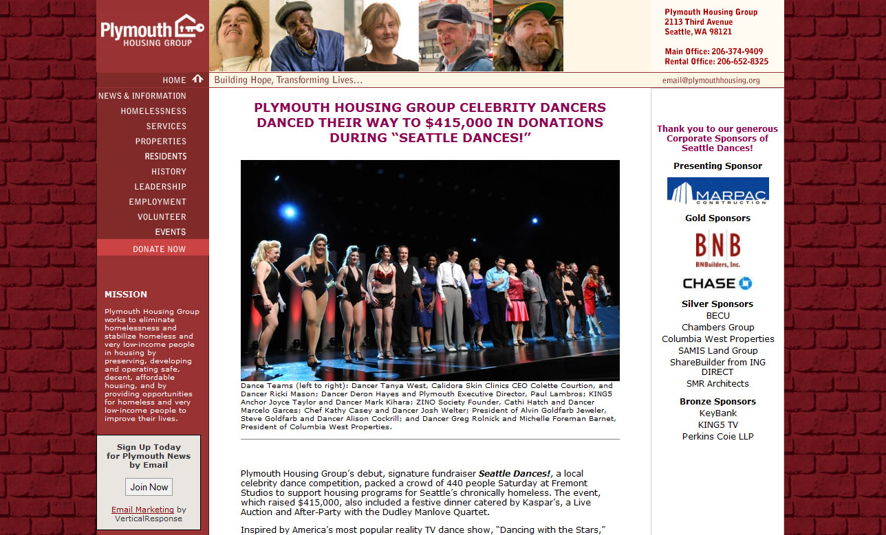
Criteria:
Call for action: DONATE NOW button on every page in the primary navigation located in the left column.
Social integration: Facebook – no; Twitter – no; Mobile App – no
E-newsletter: Yes, and they call it “Email marketing” by VerticalResponse
Search Feature: No
Visual/design:
- Plymouth Housing Group logo in the left hand corner does nothing, which is a problem since most users know that location and org logo should typically take you back to the home page.
- Built with a red brick background, the site is fairly clean in appearance and as such, nothing really jumps out to grab your attention.
- Contact information is in the top right hand corner and the primary navigation bar is presented as the left hand column.
- There is strong consistency in the template for the site and in addition to: Home; News & Information; Homelessness; Services; Properties; Residents; History; Leadership; Employment; Volunteer; and Events; DONATE NOW is posted on every page in the exact same spot.
- Down side, the “donate online” link takes you to page with a bunch of broken images. However, you don’t have to donate online even though it’s the top option prior to donate by phone, donate by mail, and major gifts.
- The bulk of the text is on white and in the center of the page.
- Mission statement is missing from the following pages: News & Information, Services, Properties, Residents, History, Leadership, Employment, Volunteer, and Events, even though it seems as if it’s part of the primary navigation in the left hand column.
- Can’t tell how current the site is, unless you are looking for employment. July 10, 2009 is the most current “news & information” item.
- Photos are nice and used to accent the site. They are also mostly of people.
Overall: The red brick make the site top dark and on a smaller screen, I don’t really want to look at it. My guess is that it’s an old site and Plymouth should update it.

Org name: Homestead Community Land Trust
Site name and URL: www.homesteadclt.org
Mission Statement: None
Tag Line: Creating and permanently preserving affordable homes in Seattle.
Audience (your deduction): Potential home owners, donors, and community members who want more information on the organization and its programs.
Business/Site Goals (your deduction): Raise money and provide information on how to become a homeowner
Technologies used (your deduction): CSS
Homepage screenshot:
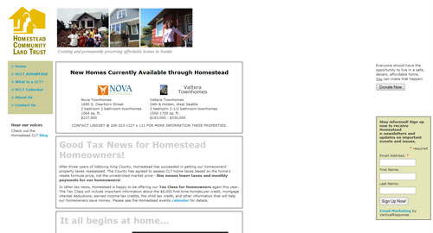
Criteria:
Call for action: DONATE NOW button on every page.
Social integration: Facebook – no; Twitter – no; Mobile App – no; blog – yes, http://homesteadclt.typepad.com
E-newsletter: yes, “E-mail marketing” by VerticalResponse
Search Feature: No
Visual/design:
- Homestead Community Land Trust logo in the left hand corner take you back to the homepage, which is what most users expect it to do.
- Everything is built on a white background and seems to spread out, almost as if the accidently left a large space between their main content section and the right hand items that include “Donate Now.”
- "Contact Us" is a text link in the primary navigation listing found in the left hand column.
- There is strong consistency in the template for the site and in addition to: Home, HCLT Advantage, What is CLT?, HCLT Calendar, About US and Contact us. Donate Now is posted on every page in the exact same spot.
- The Donate Now takes you to an online form, which is nice. However, the contact information on the form is very small and doesn’t display well on a smaller screen. And what if users don’t want to donate online? Also, logo for HCLT on the form page doesn’t match the site.
- The bulk of the text is on white and in the center of the page.
- Mission statement is missing from the following pages: News & Information, Services, Properties, Residents, History, Leadership, Employment, Volunteer, and Events, even though it seems as if it’s part of the primary navigation in the left hand column.
- Can’t tell how current the site is, unless you are looking for employment --- July 10,2009 is the most current “news & information” item.
- Photos are nice and show people in front of homes, connection to the idea that they want to see you in a picture --- in front of your new home.
Overall: Too much white and loosely put together. The blog looks good, and perhaps HCLT needs to decide if it wants to stick with the site or move to a CMS such as Wordpress.

Org name: United Way of King County
Site name and URL: http://www.uwkc.org/
Mission Statement: Amazingly, no mission statement is available. Based on tabs on the news site and research subject matter the takeaway is that United Way of King County focuses on three issues in the King County community-- early learning, homelessness and hunger.
Tag Line: Delivering help and hope to those who need it most
Audience (your deduction): The community, with particular emphasis on donors and volunteers. Age group ranges from younger and older members of the community who may have more time for volunteering, to professionals who have disposable income to donate. Corporate HR/CSR seeking to identify employee volunteerism opportunities.
Business/Site Goals (your deduction):
- Engage the community to donate and/or volunteer
- Demonstrate tangible impact
- Position United Way as a credible source of information on critical issues facing the community
Technologies used (your deduction): IIS 5.0 and ASP.net (server), XHTML Transitional, CSS, Javascript
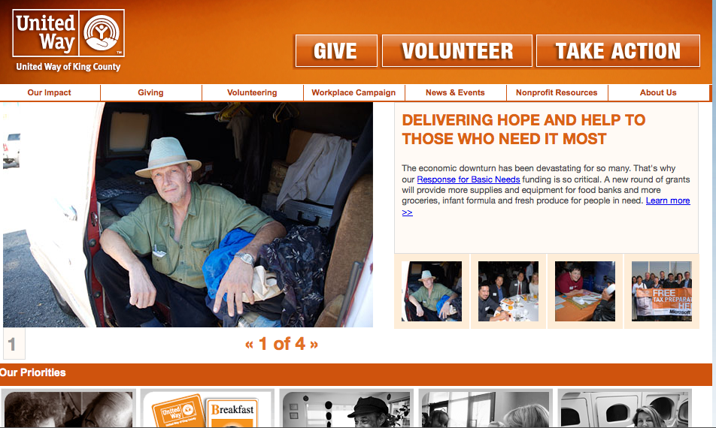
Criteria:
Call for action: Very clear on the top right of the home page. Donate, Volunteer, Take Action
Social integration: Strong—FB, Twitter, YouTube links on every page; content on social networks is informative, but very little online community engagement. Most content is simply “pushed”
E-newsletter: opportunity to subscribe to a breadth of e-newsletters according to subject matter, but no access to that content directly from the newsletter site. I did find past newsletters (as PDFs) through search.
Search Feature: based on Google custom search engine. Fast, seemingly accurate.
Visual/design: good colors, good navigation usability
Overall:
Site is well constructed and visually appealing (in a simple way). Messaging regarding priorities and call-to-action is very effective. Community oriented. Navigation is nice and straightforward – easy to find things.
Only weird thing is that there is no stated “umbrella” mission statement.

Org name: Seattle Works
Site name and URL: http://www.seattleworks.org/HomePage/index.php/home.html
Mission Statement: Seattle Works offers opportunities for people to serve as active volunteers, informed voters, savvy charitable donors and knowledgeable community leaders.
Tag Line: Seattle Works informs, connects and inspires people in their 20s and 30s to take action in our community.
Audience (your deduction): Seattle residents, 20-40 years old, who are interested in giving back to their communities
Business/Site Goals (your deduction):
- Facilitate and promote volunteering
- Connect people with projects
- Promote and foster community leadership
Technologies used (your deduction):
Apache, PHP, HTML 4.0 Transitional DTD, XHTML Transitional, CSS, Javascript
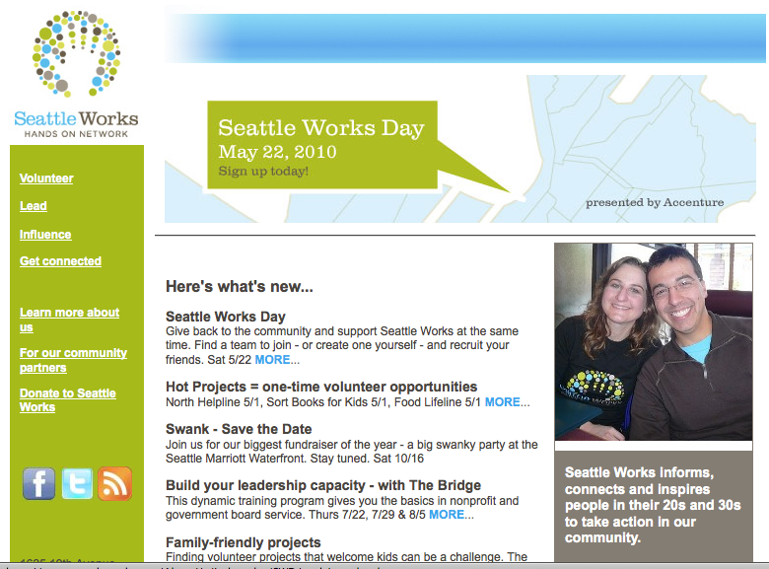
Criteria:
Call for action: Not well articulated on the home page. Tag line is positioned as a caption. It should be included in the header or directly under it.
Social integration: FB and Twitter, no YouTube. FB and Twitter content up to date and both sites seem to foster quite a bit of interactivity.
E-newsletter: No, just RSS feed
Search Feature: None.
Visual/design: Colors are pleasing, but page is weirdly positioned. It covers two-thirds of the screen horizontally with a huge whitespace on the right third of the screen. Good colors, good navigation usability.
Overall: Consider this a lightweight site with basic photos with people of the right age group. Forward navigation is pretty clean, but no one-click retreating to the home page. The primary function of connecting people with projects is presented well in the form of calendar with information on whether more volunteers are needed or capacity has been reached.
This organization ostensibly could be a feeder site for H4H.

